***ORDER CONFIRMATION***

***RPI 3B+***

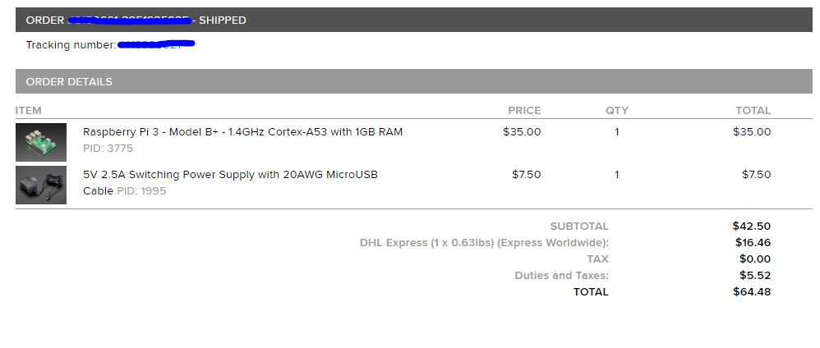

***(Sen-11574) Pulse Sensor***

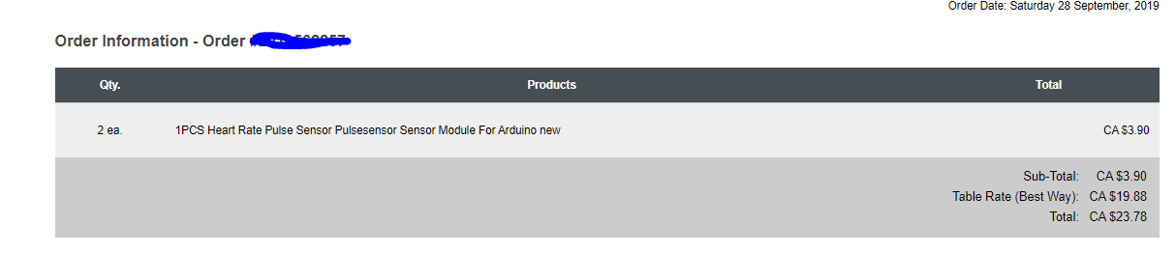

***MCP3008***